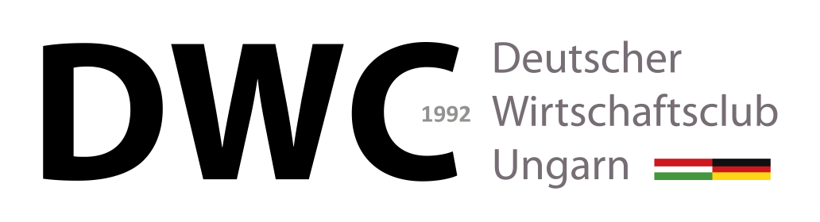
Deutscher Wirtschaftsclub Ungarn –
Application Form
Name:
Date of Birth:
Company/Branch/Employee:
Position:
Telephone (direct):
Mobile:
E-Mail:
Company name / Billing address (address and Hungarian or EU VAT [tax] number):

Annual member’s fee
- Basic fee 175.000 HUF contains all events without a special status
- Option 1. 220.000 HUF contains the basic fee + 2 Tickets for the Ball
- Option 2. 250.000 HUF contains Option 1. + 2 Tickets for the Christmas party
- Option 3. 265.000 HUF contains Option 2. + 2 Tickets for the Oktoberfest

For further information please contact the secretariat at mail@dwc.hu
I hereby declare that I am ready to support and further the goals of the
Deutscher Wirtschaftsclub Ungarn, as well as to pay the yearly membership fee in time.
I am familiar with and understand the Statutes of the Club.

___________________________ ___________________________
Date Signature

